UserManagement Web API – Documentation:

1. Created a web api application using .NET Core API, visual studio.
2. Created a user model
3. Created a DB Context class.
4. Have written connection strings in the appsettings.json to connect with database(Sql Server)
5. Created a repository pattern and implemented list,add,edit/update,delete functions.
6. Created a web api controller.
7. Injected repository in the controller
8. Written all the crud methods in the API controller.
9. Db script – table created.
10. Using postman – crud operation tested.

CRUD – Web API with response:

User List:

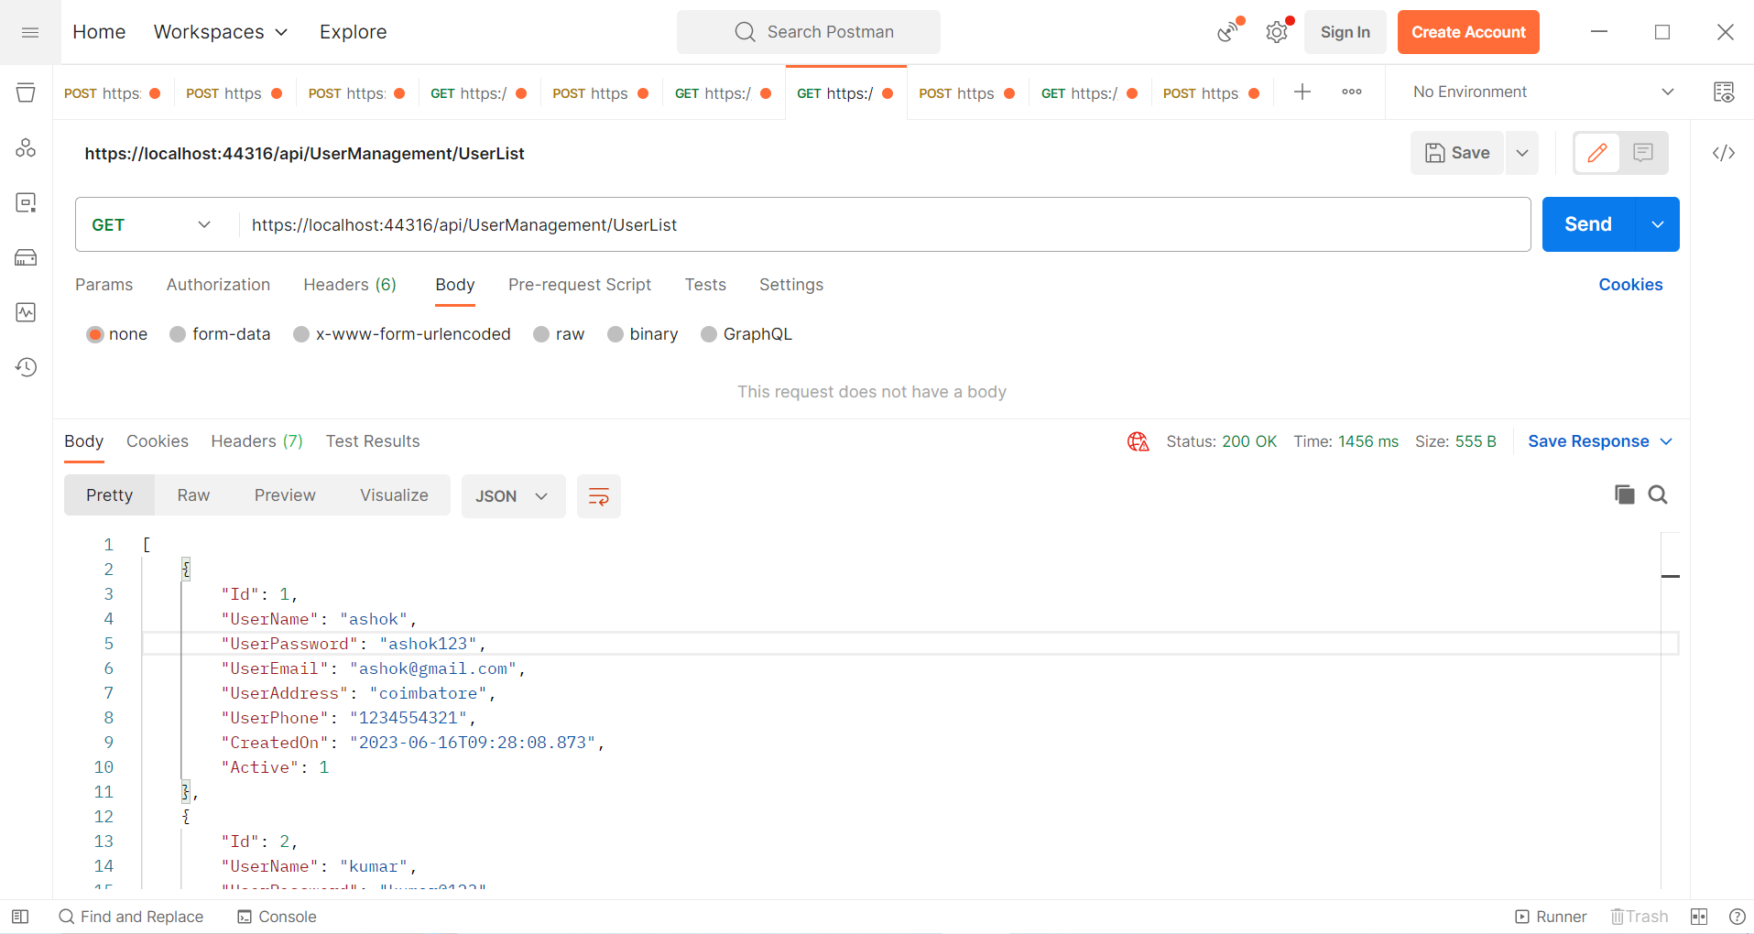

Create/Add User:

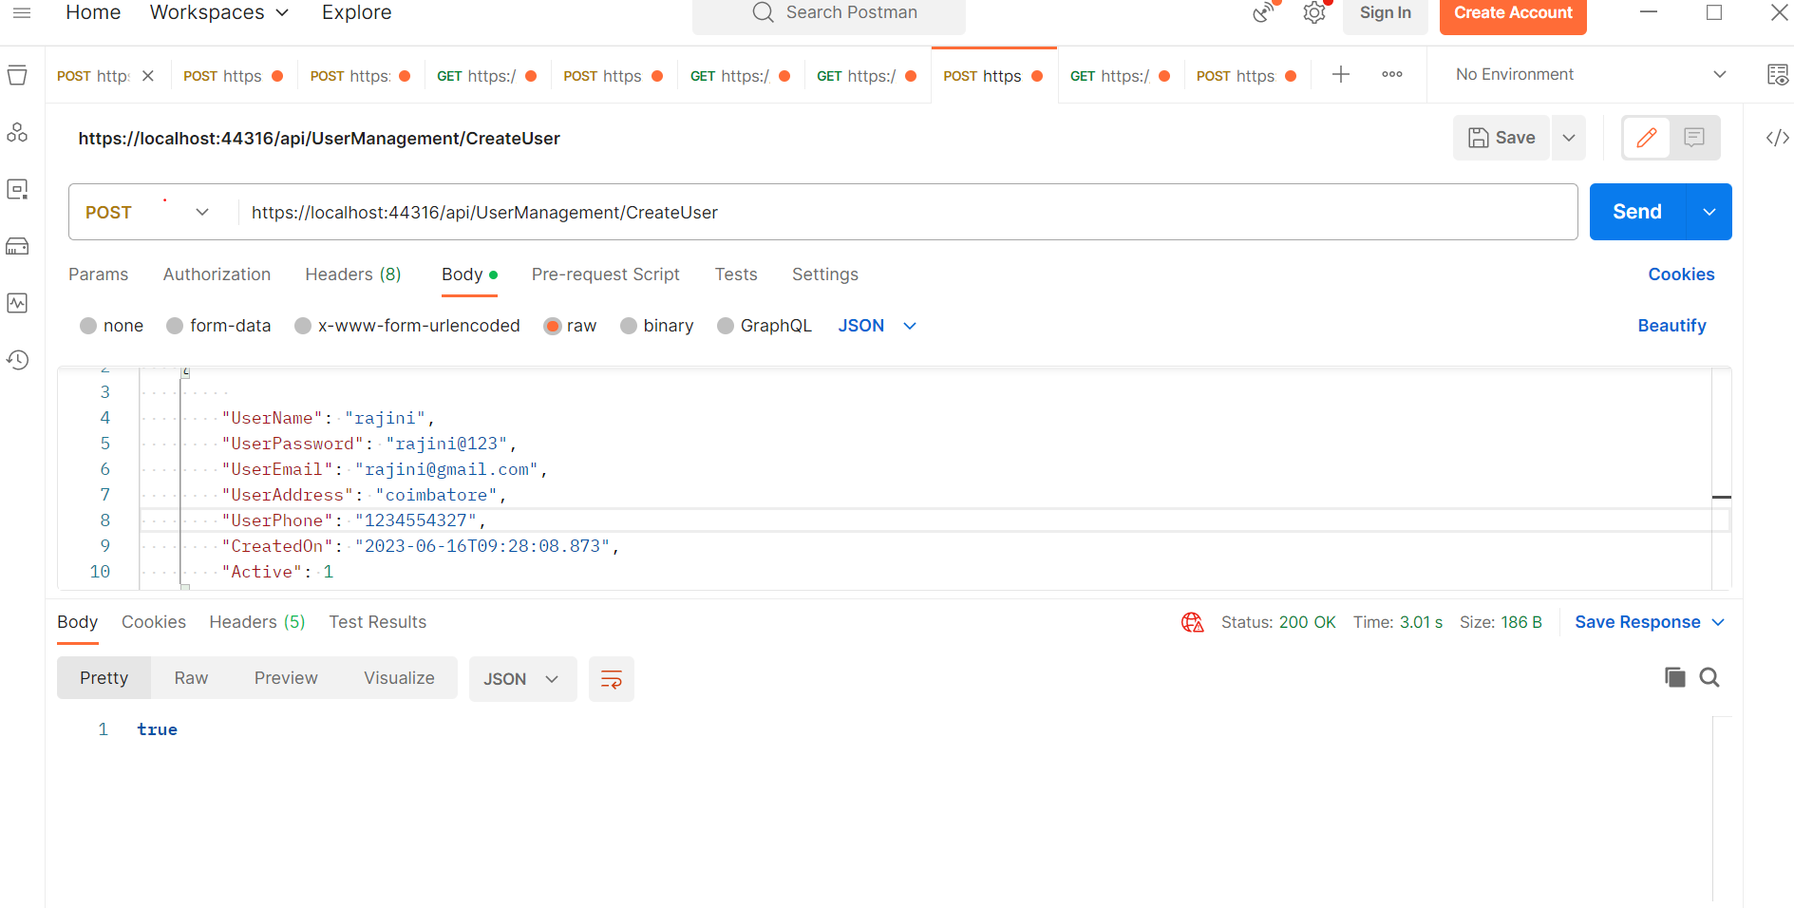

Edit:

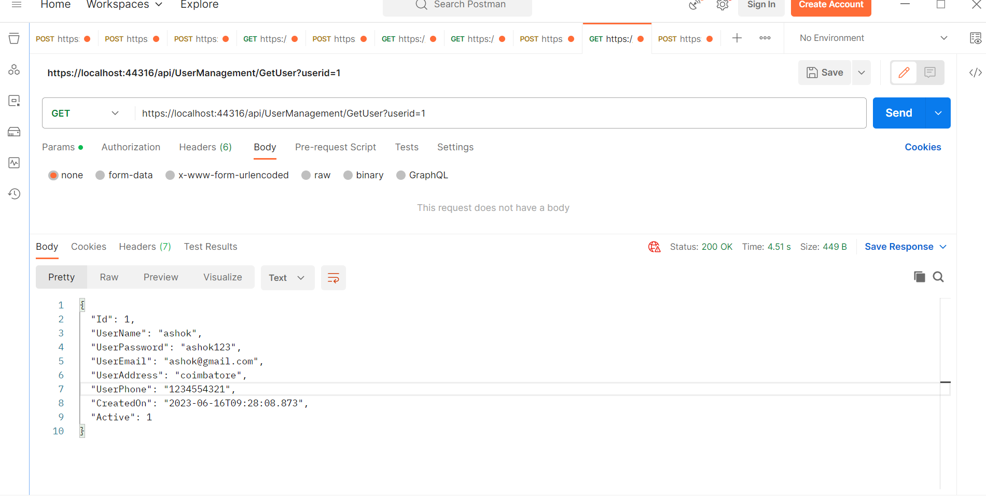

Update:

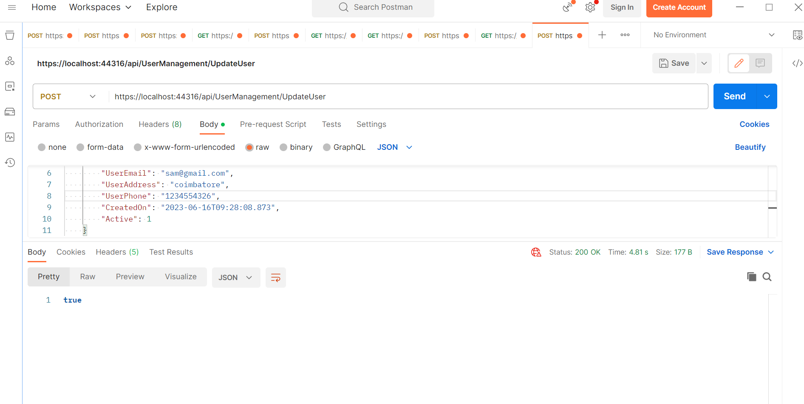

Delete

